Project Report:

Blood Evaluation Program

**Member 1:** Areeba Batool **Roll No:** 20K-0341 **Section:** BDF (2A)

**Member 2:** Ahsan Raza **Roll No:** 20K-0137 **Section:** BDF (2A)

**Member 3:** Hafsa Farhan **Roll No:** 20K-0127 **Section:** BDF (2A)

### Acknowledgment

We acknowledge and cordially thank Google for assisting us in finding the biological and medicinal facts and figures which we have incorporated in our project. A special gratitude to all our friends whose contribution in stimulating suggestions and encouragement, helped us to coordinate the project. Furthermore, we would also like to acknowledge members of stack overflow forum for their crucial role in making the source code error free.

Introduction

The program will instruct users to enter their personal information and will allow users to enter their blood test (Complete Blood Count, Basic Metabolic Panel, Vitamins) results. The patient's personal information as well as the values of the blood test result will be stored in a database file.

Upon conditional analysis with predefined values the program will then tell users what symptoms patients can feel if they have a deficiency or intoxication in that specific component. With the help of the aforementioned analysis, the program will evaluate the disease and recommend suitable medications for the patient and prompt the possible time duration during which the disease or symptom might disappear.

### Tools and technologies used

This project is a console-based application developed using C++ programming language with Visual Studio and DevC++ primarily used as the development environment.

### 

### Programming concepts used

A variety of programming concepts were included in this project to optimize the code while keeping it simple to use and understand.

Classes were used to setup a blueprint for taking inputs, storing them and applying conditions to provide results. Functions were used to carry out conditional analysis using IF/ELSE statements. An extensive use of file handling was made to store, modify and call up data from text files as per requirement. Multi-level Inheritance was used to connect classes. Operator overloading was used to print date for next appointment. Parameterized constructors and input statements were used to get data and object pointer was made in main function to call object’s function.

UML Diagram

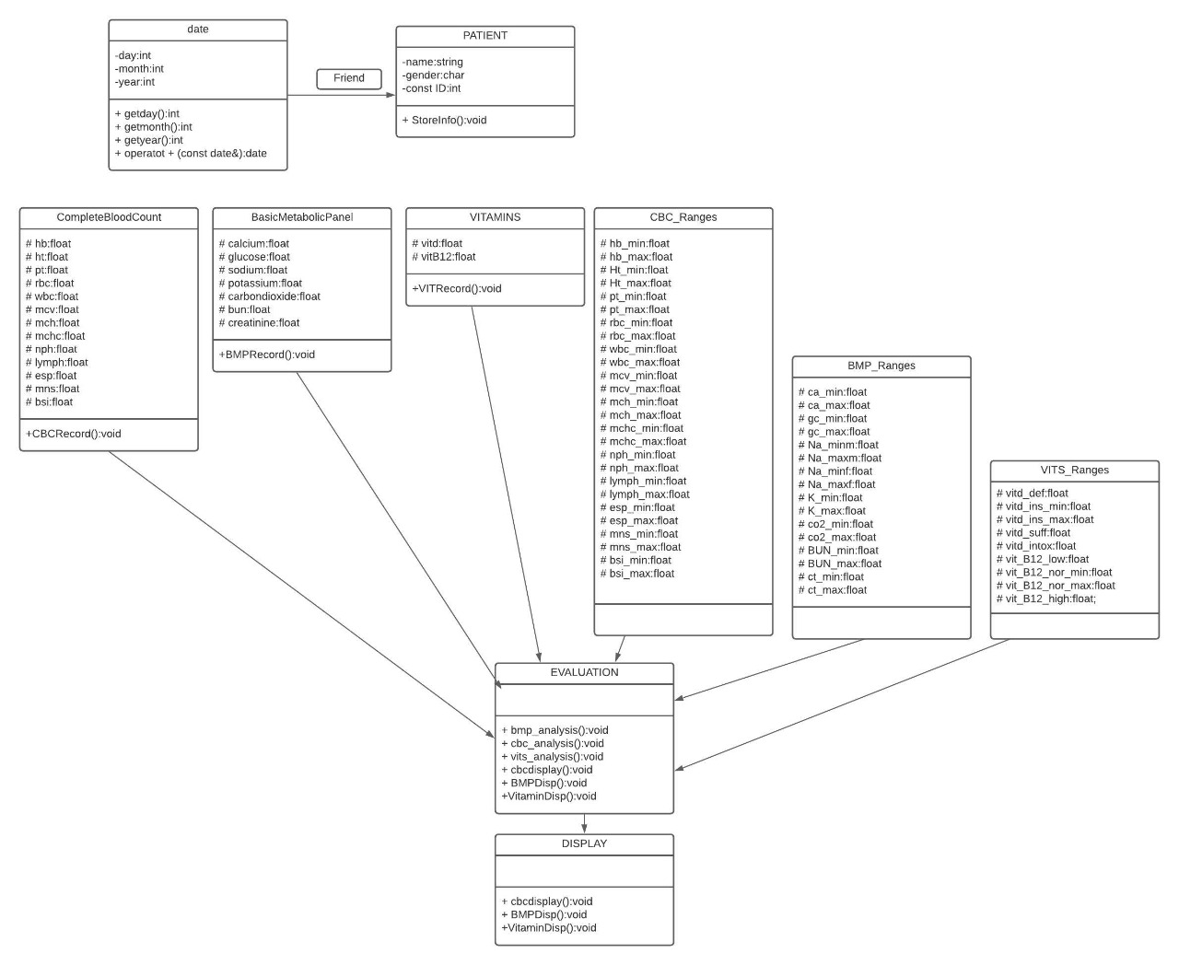

FUTURE WORK

This project can be extended to support more types of evaluation and provide results based on the same lines as used currently in the project. Secondly, object array can be created to cater more than one function in one go.

Link to the project

https://drive.google.com/drive/folders/1Eha7Zt9Ao6oWxcIkuajwO_YawvMwSc7v?usp=sharing